**Results**

Procedure 1: Measure the True Magnification of an objective

To determine whether our microscope is a finite-tube length microscope or an infinite-tube length microscope, we measured the true magnification of our objective. Each group member observed the ruler using the eyepieces once and get following data:

**Table 1 Length on eyepiece and on ruler**

|  |  |  |  |  |
| --- | --- | --- | --- | --- |
| Length on Eyepiece(mm) | 21.50 | 17.12 | 17.11 | 17.11 |
| Length on Ruler(mm) | 5.00 | 4.00 | 4.00 | 4.00 |
| mmeas | 4.3 | 4.28 | 4.2775 | 4.2775 |

The average measured magnification is 4.2858, standard deviation σ = 0.010897247.

Then we measured two distances: the distance between the objective lens and the sample(o), the distance between the objective and eyepieces(i).

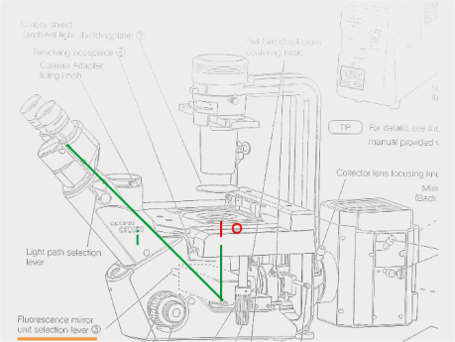

**Figure 1 The distance we measured**

**Table 2 Length on eyepiece and on ruler**

|  |  |  |  |
| --- | --- | --- | --- |
| o(cm) | 1.652 | 1.650 | 1.599 |
| i(cm) | 53.46 | 53.80 | 53.12 |
| mTheo= | 32.36 | 32.61 | 33.22 |

We have ${\overline{m}}_{theo}=32.73$, σ = 0.442379927.

There is a significant difference between true magnification and the theoretical value. It proved that our microscope is an infinite-tube length microscope.

Procedure 2: Alter the Numerical Aperture of an Objective

In this procedure we kept the position unchanged and place pinholes of different sizes on the objective lens.

The smaller the pinhole, the smaller the angle, and the smaller the resolution.

(d)

(c)

(b)

(a)

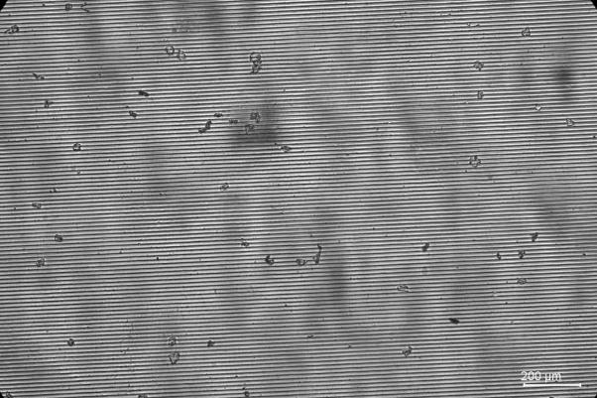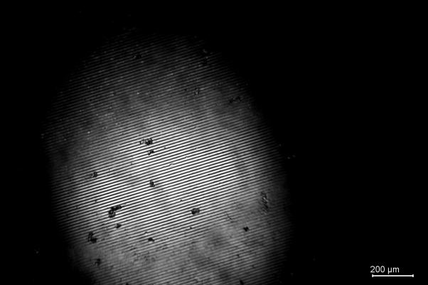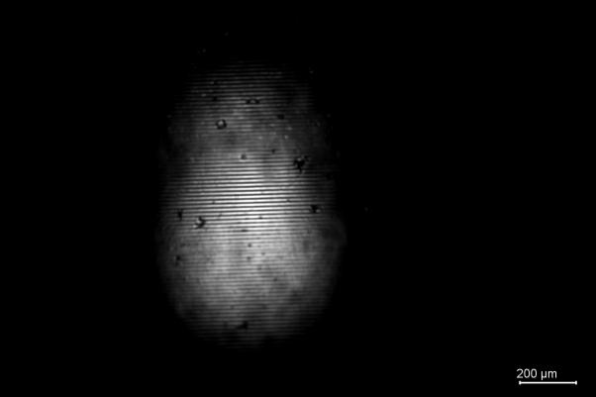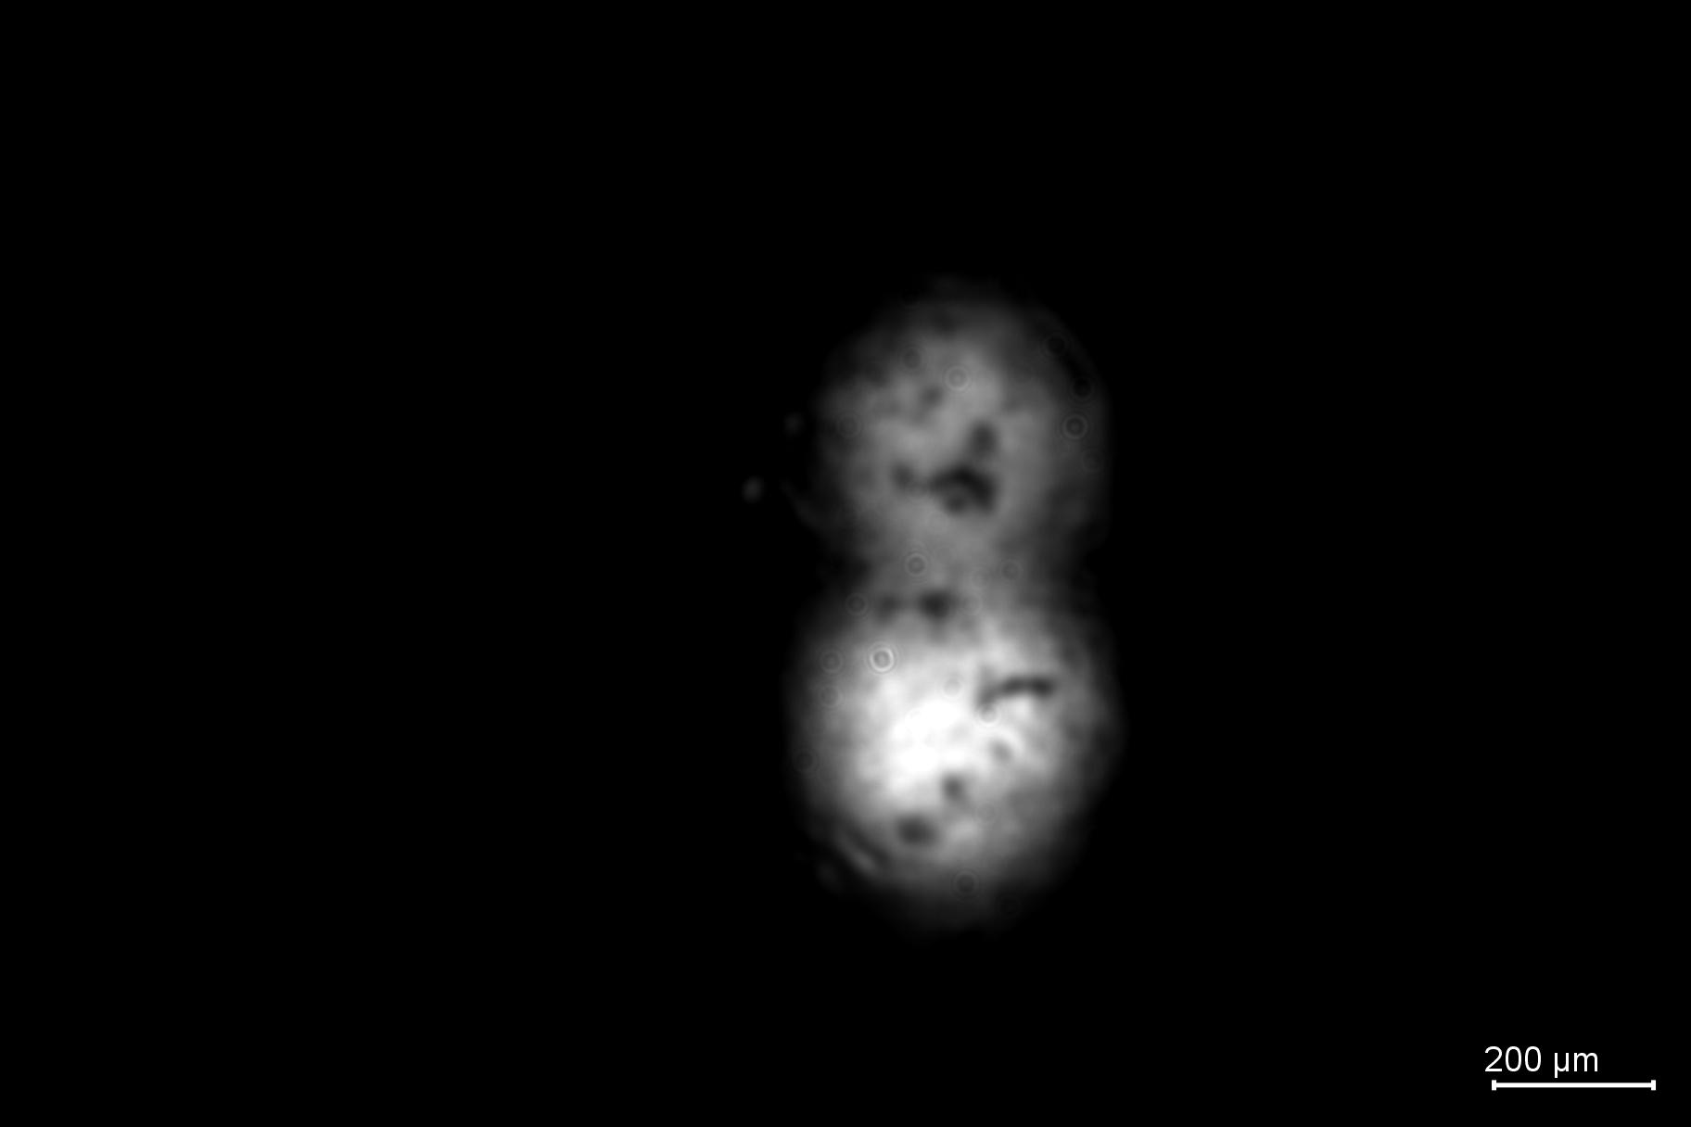

(a)

**Figure 2**

**70lines/mm grating without pinhole(a)，**

**with pinhole aperture 1000μm(b)，500μm(c)，200μm(d)**

It is apparently that the bright spot is getting smaller when pinhole aperture is getting smaller. Moreover, the resolution is smaller. Stripes are observed in figure 2 to figure 4, but there is no stripes in figure 5.

Also we found diffraction phenomenon in figures which contain pinhole. We can see more than one spot in the camera.

Then we replaced the grating with an 110lines/mm grating.

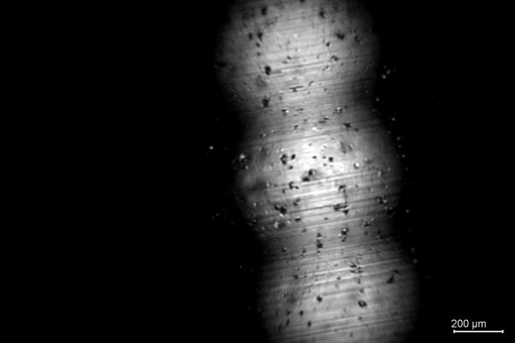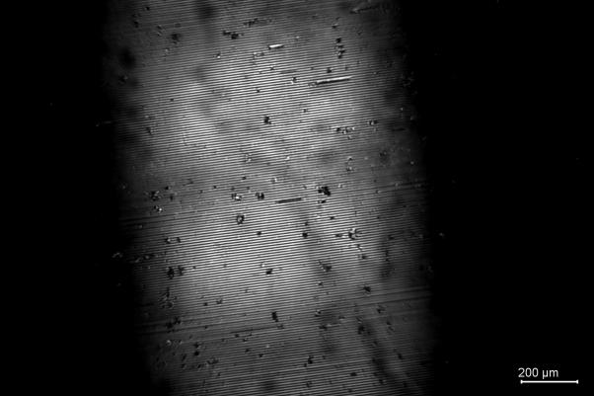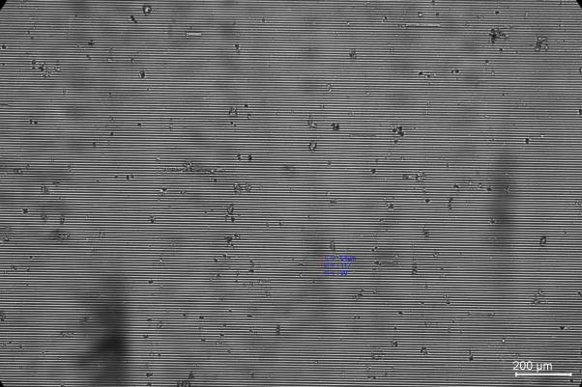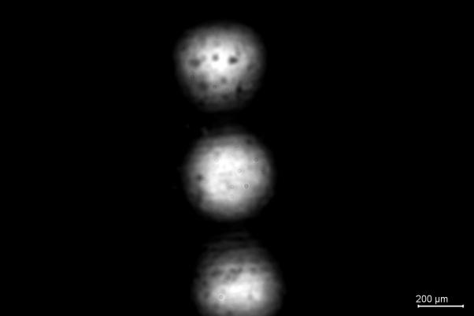

(d)

(c)

(b)

(a)

**Figure 3**

**110lines/mm grating without pinhole(a)，**

**with pinhole aperture 1000μm(b)，500μm(c)，200μm(d)**

This time the fringe spacing is reduced. As a result, the stripes are unclear from 500μm pinhole.

The diffraction effect became stronger, and we saw three spots in view at most.

Procedure 3: Phase Microscopy

We use the regular bright field and the phase contrast mode to observe MC3T3 cells in the same place.

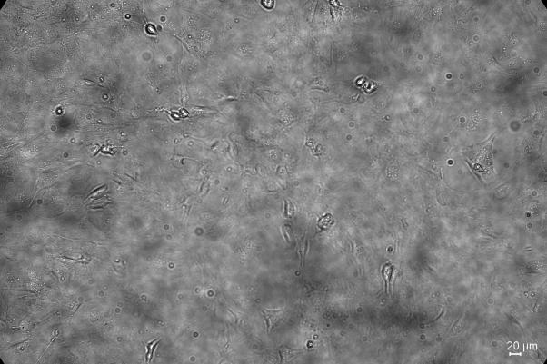

**Figure 10 Cell image under regular bright field**

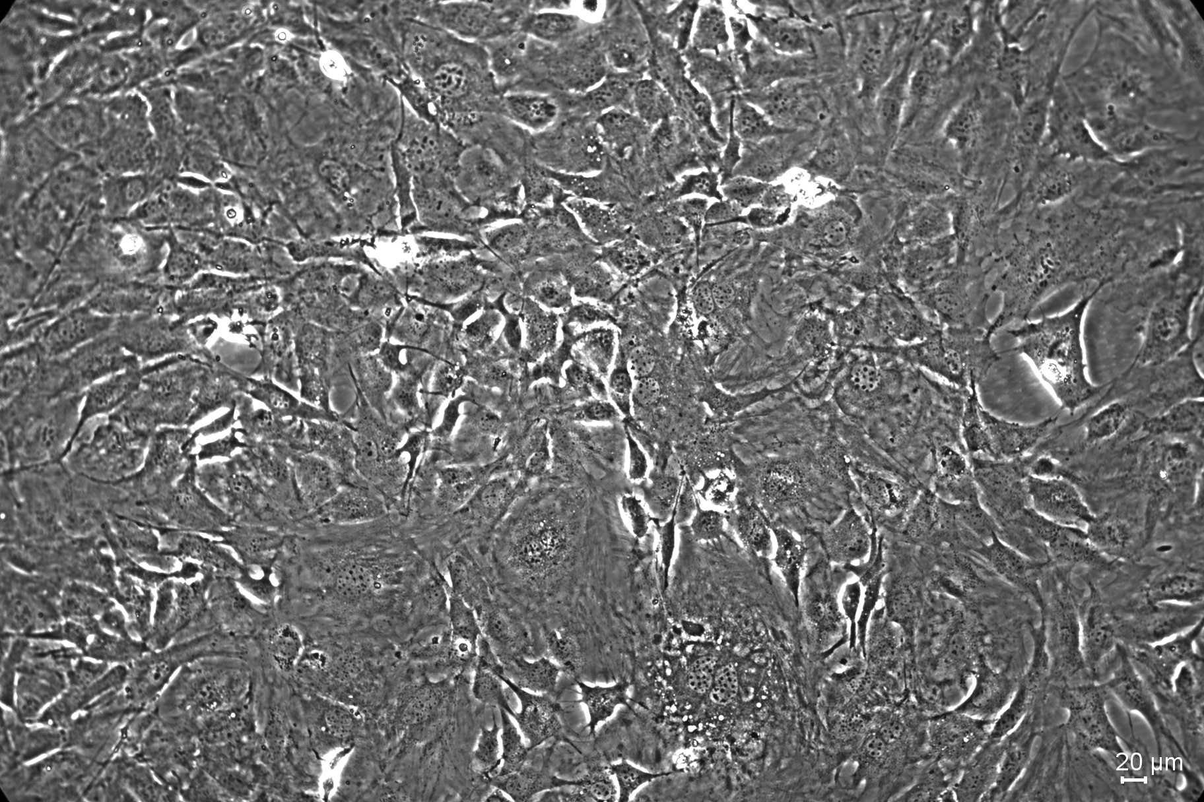

**Figure 11 Cell image under phase contrast mode**



**Cell**

**Figure 12 Part of figure 11**

We observed the cells under phase contrast mode first and then changed to the regular bright field. We didn’t changed the focus.

Under bright field, we cannot see any clear objects. Almost everything is in same colour. Under phase contrast mode, we found that the cells are in dark field with bright edges. In figure 12, we even saw intracellular structure.

Procedure 4: Fluorescence Microscopy

In this procedure, we use Mercury lamp as light source to excite different fluorescent stains.

Three stains(MitoTrackerTM Red CMXRos, Alexa FluorTM 488 phalloidin and DAPI)

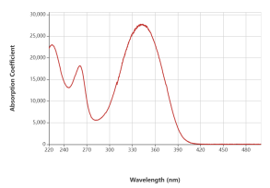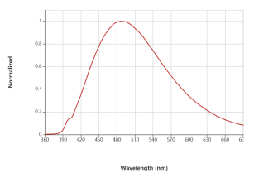

**Figure 15 Absorption and fluorescent spectrum of DAPI**

Under UV light, DAPI emits blue light, which showed the nucleus. We found that the nucleus are in the center of the cells. The figure we got from the Capture is black and white, and we stained it blue.

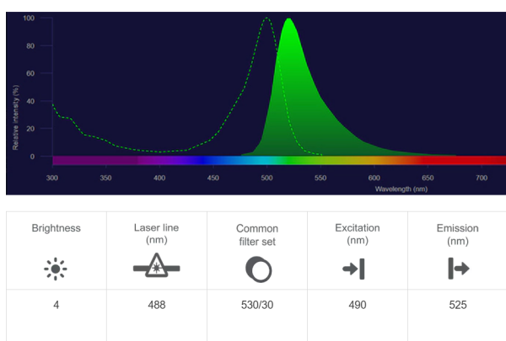

**Figure 18 Absorption and fluorescent spectrum of Alexa 488**

Alexa 488 emits green light under blue light. This stain binds F-actin and show its structure. We were able to see cytoskeleton one by one. The figure we got from the Capture is black and white, and we stained it green.

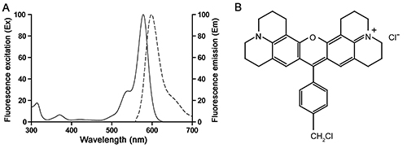

**Figure 21 Absorption and fluorescent spectrum of MitoTrackerTM Red CMXRos**

MitoTrackerTM Red CMXRos binds mitochondria and emits red light under green light. Mitochondria are in the cell and arrange around the nucleus. The figure we got from the Capture is black and white, and we stained it red.

(d)

(c)

(b)

(a)



**Figure 22 RGB three channels and merge of the three channels**

The three figures are merged by camera software. We took the photos in the same position and observed cellular structures. We found nucleus, cytoskeleton and mitochondria in one cell and understood their arrangement.